Eldora Processor Upgrade – Data Arbitration

Tom Brimeyer
NCAR/EOL – RTF
Rev 0.1
Overview

The new FPGA based PCI(64 bit bus) signal processors for the Eldora Radar are responsible for producing both Pulse Pair vector and power data(A, B, P) and a limited number of raw IQ data samples. The data is moved from the signal processor to the signal processing PC using a 64 bit DMA Engine. The data must be packed together in 64 bit sections and stored within an output FIFO prior to being transferred by the DMA engine to the signal processing PC.

The DMA channels, within the FPGA, are arbitrated in such a way that each channel is cyclically monitored and then flagged when it is ready to transfer data. This transfer occurs upon the next availability of the PCI bus.

Data Stamp

Each pulse of data will contain its own unique data stamp. This data stamp consists of a DMA Channel ID(32 bits), PRT ID(32 bits), and Pulse Count(32 bits). The DMA Channel ID is fixed and ranges from 1-16 with 1-8 representing the 8 DMA channels of the FORE signal processor and 9-16 representing the 8 DMA channels of the AFT signal processor. Below is a table consisting of the 16 DMA channels and their corresponding data.

Table 1. – Corresponding DMA Channels, IDs, and Data
DMA Channel | DMA Channel ID | Data
0 | 1 | FORE Radar Chan. A - IQ
1 | 2 | FORE Radar Chan. A - PP
2 | 3 | FORE Radar Chan. B - IQ
3 | 4 | FORE Radar Chan. B - PP
4 | 5 | FORE Radar Chan. C - IQ
5 | 6 | FORE Radar Chan. C - PP
6 | 7 | FORE Radar Chan. D - IQ
7 | 8 | FORE Radar Chan. D - PP
8 | 9 | AFT Radar Chan. A - IQ
9 | 10 | AFT Radar Chan. A - PP
10 | 11 | AFT Radar Chan. B - IQ
11 | 12 | AFT Radar Chan. B - IQ
12 | 13 | AFT Radar Chan. C - IQ
13 | 14 | AFT Radar Chan. C - IQ
14 | 15 | AFT Radar Chan. D - IQ
15 | 16 | AFT Radar Chan. D - IQ
The PRT ID is the 32 bits of data following the DMA Channel ID and consists a value of either a ‘1’ or ‘2’. For single PRT operation, all of the PRT IDs will consist of a value of ‘1’ which signifies the first pulse of the PRT. For dual PRT operation, the PRT IDs will alternate between the values of ‘1’ and ‘2’ and always beginning with the value of ‘1’. In this case, the value of ‘1’ signifies the first pulse of the PRT and the value of ‘2’ signifies the second pulse of the PRT.

The Pulse Count is the 32 bits of data following the PRT ID and consists of an incrementing value starting with ‘0’ and incrementing by +1 with every pulse. The “start time” of the radar will be noted and the true pulse timing will be calculated based off of the PRT and the Pulse Count. The Pulse Count acts as the unique identifier for each pulse. For dual PRT operation, the Pulse Count will only increment once for every dual PRT.

Data & Formatting

Each of the Eldora signal processors(Fore and Aft) consists of 4 radar channels. Each radar channel is responsible for producing 2 sets of data, one IQ data set and one Pulse Pair data set. Each of these data sets is contained within its own DMA channel. Thus, there are a total of 8 DMA channels per signal processor. The data formats are described below.

IQ Data

The individual I or Q data format is signed [16:15]. Each I or Q sample consists of 16 total bits with 1 sign bit and 15 decimal bits. This limits the minimum and maximum values to +/- 0.9999. This is directly correlated with the 2Vpp input range of the signal processors ADC.

The IQ samples are packed together as they are produced [I(16 bits):Q(16 bits)] to form a 32 bit structure. Since the DMA Engine utilizes 64 bit transfers, these structures are packed together in the following fashion. Subscript denotes the sample number beginning with time ‘0’ and ending with time ‘N’. The MSB is to the left and LSB is to the right.

[I₀:Q₀:I₁:Q₁] (64 bits)
[I₂:Q₂:I₃:Q₃] (64 bits)
.
.
.
[I_{N-1}:Q_{N-1}:I_{N}:Q_{N}] (64 bits)

Pulse Pair Data

The Pulse Pair Data consists of 3 different data parts, A data, B data, and P data. All three data parts are 32 bits. Both the A data and B data are formatted as signed [32:31]. The P data is formatted as unsigned [32:32].

The Pulse Pair data samples are packed together as they are produced. Since the DMA Engine utilizes 64 bit transfers, these samples are packed together in the following fashion. Subscript denotes the sample number beginning with time ‘0’ and ending with time ‘N’. The MSB is to the left and LSB is to the right.

[A₀:B₀] (64 bits)
[P₀:A₁] (64 bits)
[B₁:P₁] (64 bits)
.
.
.
[A_{N-1}:B_{N-1}] (64 bits)
[P_{N-1}:A_{N}] (64 bits)
[B_{N}:P_{N}] (64 bits)

The FPGA FIFO Storage Timing figure below demonstrates how the data is moved from the Pulse Pair Processor into the storage FIFOs where it will wait to be DMA transferred to host PC memory..

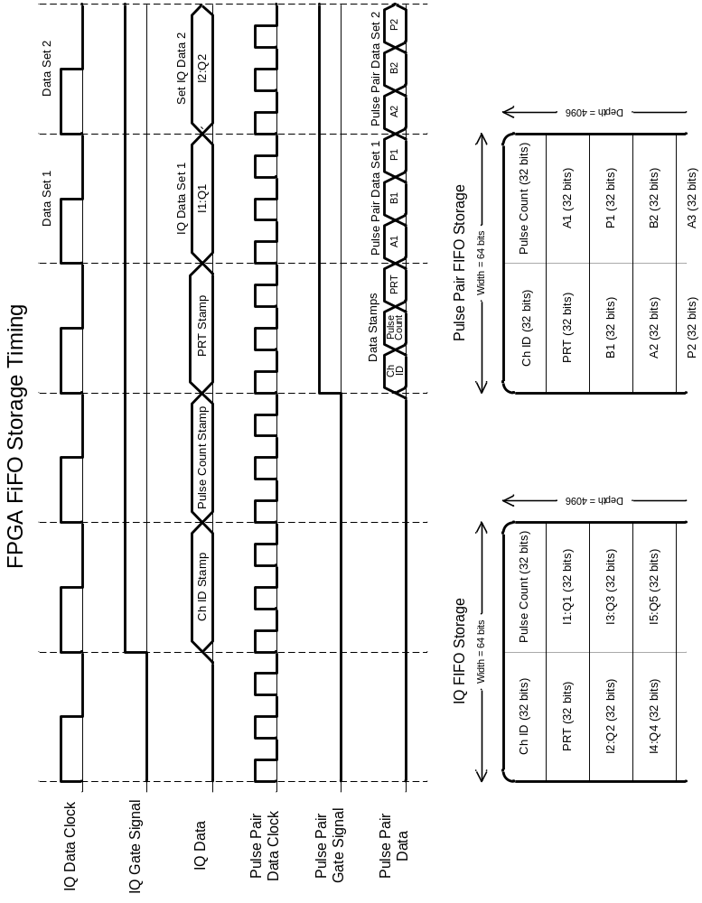

At this point, the streaming data will reside in the FIFOs where it will be waiting to be transferred to PC memory via the 64-bit PCI bus. This is done via 64-bit DMA transfers. The FPGA based Signal Processor sequentially monitors FIFO, to see if this data threshold has been met. Once the threshold is met, and the PCI bus is enabled and available, it begins to transfer the data across the PCI bus. Upon completion, the channels are sequentially monitored again until the next threshold is met.

The limitation in the data transfer rate is determined by the speed of the PCI bus. It must be assured that the data is not produced at a faster rate than the DMA engine can transfer it off the card and into memory. If this condition is not met, data will inevitably be lost as the FIFOs will eventually overflow as they run out of storage.

It is also worth noting that some of the data arbitration is done inherently by the DMA engine. Under the circumstance that any FIFO may reach the data threshold while another DMA transfer is being performed, it will continue to collect data while it waits for the PCI bus to become free. This should also be the case for if the two cards are both attempting a DMA transfer at the same time. One card will take control of the bus while the other will wait until the PCI bus is free. This is regulated via an incoming busy signal from the PCI bus to the FPGA.

